Homework M5

After installing Jenkins we need to configure the Jenkins user:

**sudo usermod -s /bin/bash jenkins**

Now, that the shell is set as required we can set the password for the **jenkins** user

**sudo passwd jenkins**

Enter a session with the **jenkins** user

**su - jenkins**

Generate an SSH key, accept all default values, and don’t set a password

**ssh-keygen -t rsa -m PEM**

Copy the key to the localhost

**ssh-copy-id jenkins@localhost**

Let add the **jenkins** user to the **sudoers** list

**sudo visudo**

Then enter the following record

**jenkins ALL=(ALL) NOPASSWD: ALL**

Save and close the file

Restart the **jenkins** service

**sudo systemctl restart jenkins**

**Atlast we add credentials in Jenkins for out master server:**

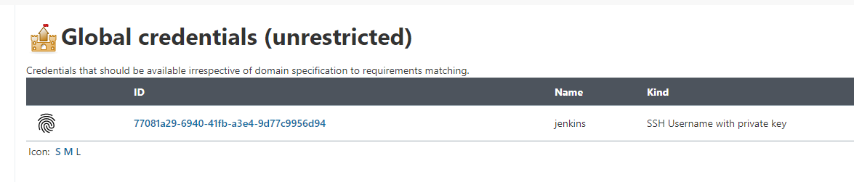

**Now we will configure the slave station:**

We must create a new **jenkins** user

**sudo useradd jenkins**

**sudo passwd jenkins**

Grant the new user **sudo** permissions

**sudo visudo**

Enter the following

**jenkins ALL=(ALL) NOPASSWD: ALL**

Now switch to the master machine

Switch the session to the **jenkins** user

**su - jenkins**

**ssh-copy-id jenkins@slave.dob.homework**

Test the connectivity with

**ssh [jenkins@slave.dob.homework](mailto:jenkins@slave.dob.homework)**

**Now we can add the slave as a Jenkins node:**

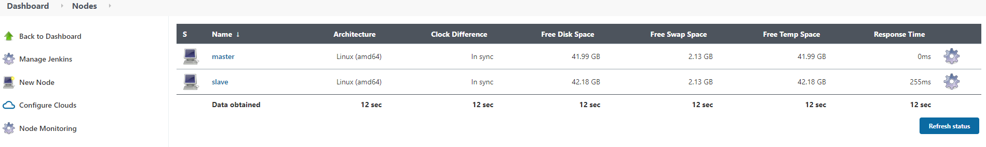

With the following configuration:

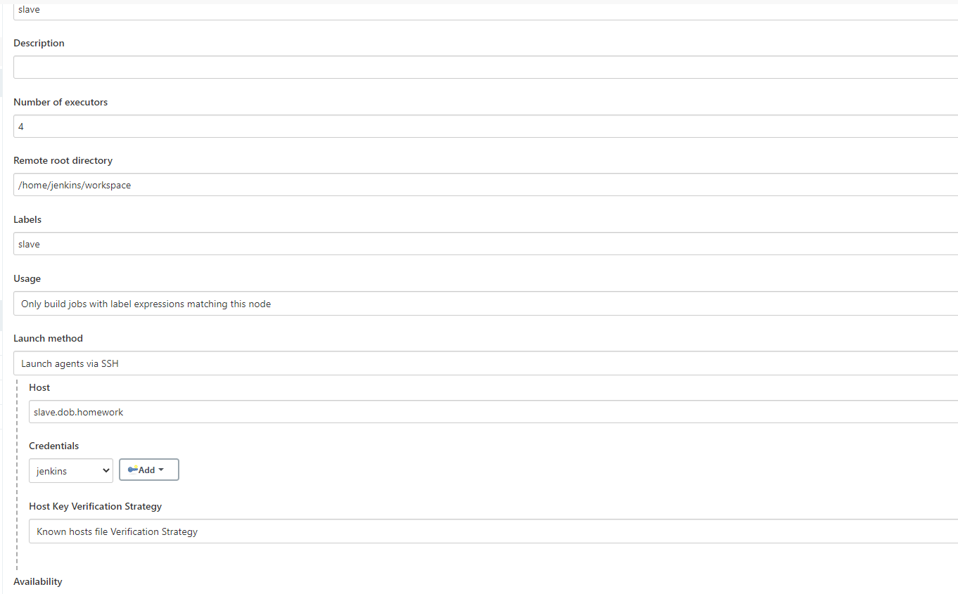

To run docker commands we need to add the jenkins and vagrant user on the slave machine to the docker group:

**sudo usermod -aG docker vagrant**

**sudo usermod -aG docker Jenkins**

Also we need to restart the Jenkins service on the master:

**sudo systemctl restart jenkins**

Now go on the slave host and create a working folder

**sudo mkdir -p /projects/www-static**

And adjust its ownership

**sudo chown -R jenkins:jenkins /projects**

Atlast we add a new job that will build the dockerfile from this repo - [**https://github.com/KostadinovK/jenkins-homework**](https://github.com/KostadinovK/jenkins-homework)

The job should look like this:

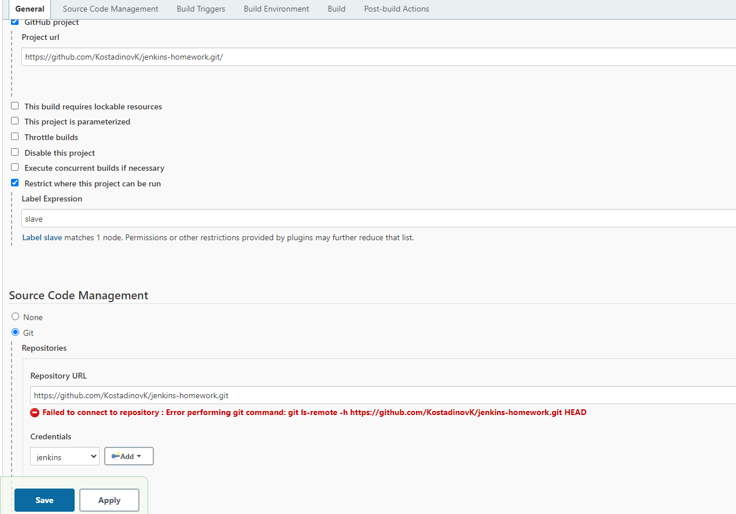

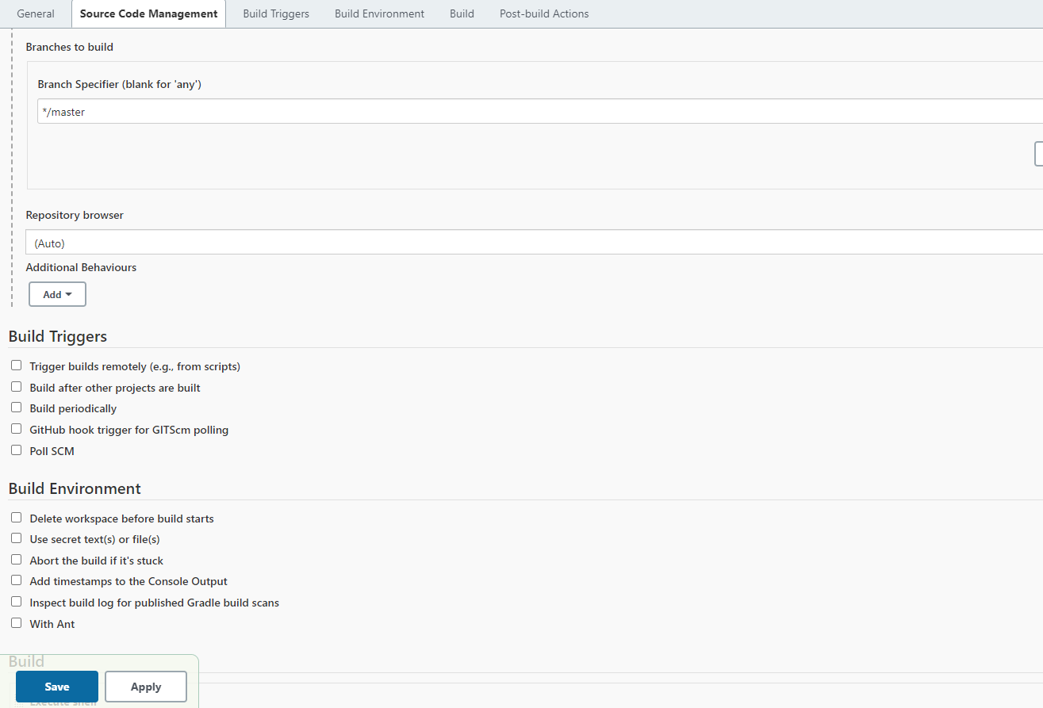

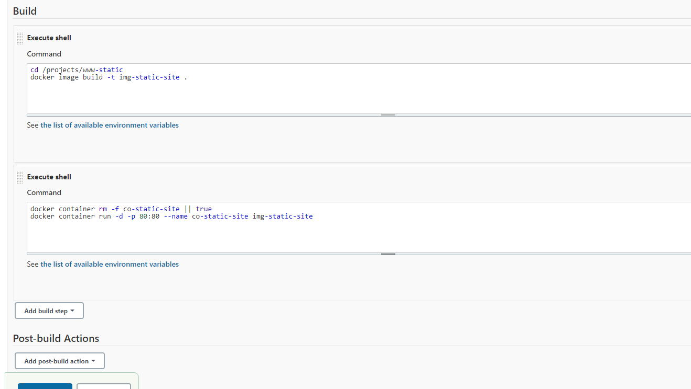

After running this job we can see the container running nginx on localhost:8088

